

Audit Conclusion

18/09

**Funds earmarked for the social services support**

The audit was included in the audit plan of the Supreme Audit Office (hereinafter the “SAO”) for 2018 under number 18/09. The audit was headed and the Audit Conclusion drawn up by the SAO member Ing. Jan Vedral.

The purpose of the audit was to investigate the provision of state budget funds to support social services and assess the achievement of objectives in this area.

The audit was carried out on the audited entity between March and October 2018.

The period under review was 2015-2017, in the case of factual context also the previous and subsequent periods.

Audited entity:

Ministry of Labour and Social Affairs (hereinafter the “MoLSA”).

The *B o a r d o f t h e S A O* at its 1st meeting held on 21 January 2019

***a p p r o v e d***  by Resolution No. 13/I/2019

***t h e a u d i t c o n c l u s i o n***  in the following wording:

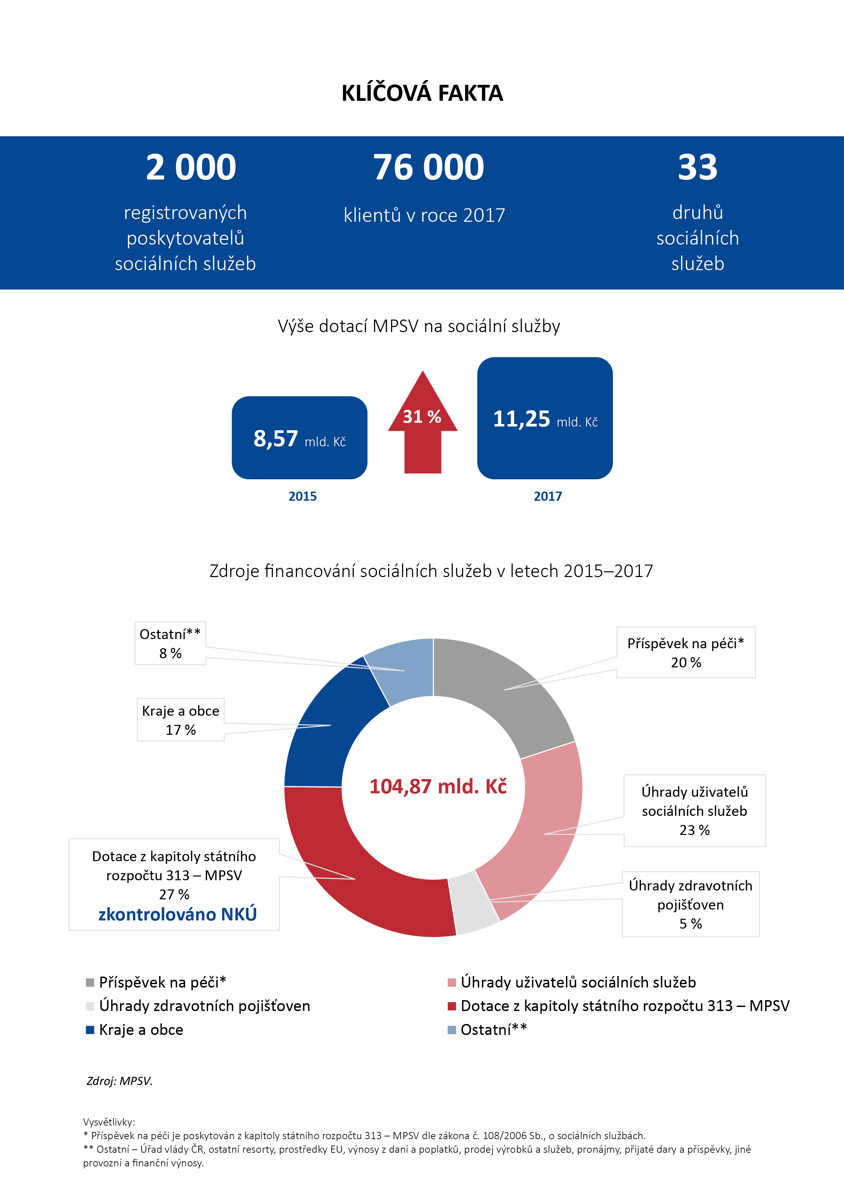¨

**KEY FACTS**

**33**

types of social services

**76,000**

clients in 2017

**2,000**

registered social service providers

The amount of subsidies from the MoLSA for social services

CZK **11.25** billion

CZK **8.57** billion

Sources of financing social services in 2015-2017

Care allowance*

20 %

Other **

8 %

Regions and municipalities

17 %

**CZK 104.87 billion**

Payments of social service users

23 %

Subsidies from state budget chapter 313 – MoLSA

27 %

**audited by the SAO**

Payments of health insurance companies

5 %

Payments of social service users

Subsidies from state budget chapter 313 – MoLSA

Other**

Care allowance*

Payments of health insurance companies

Regions and municipalities

*Source: MoLSA.*

Explanatory notes:

*The care allowance is provided from state budget chapter 313 – MoLSA pursuant to Act No. 108/2006 Coll., on Social Services.

**Other – Office of the Government of the Czech Republic, other ministries, EU funds, revenues from taxes and fees, sales of products and services, rents, received donations and contributions, other operating and financial revenues.

**CZK billions**

**CZK billions**

# I. Summary and evaluation

At the system level, the audit concerned non-investment funds in the amount of CZK 28 billion spent from the state budget in 2015-2017 to cover current expenses related to the provision of basic types and forms of social services with local and regional coverage. The audit also examined the continuous fulfilment of the visions, strategic objectives and measures resulting from the *National Strategy for the Development of Social Services for 2015* (hereinafter “NS 2015”) and the *National Strategy for the Development of Social Services for 2016-2025* (hereafter “NSDSS 2016-2025”).

**The system of providing funds for social services is set in accordance with legal regulations. The total amount of subsidy is based on the state budget law for the year in question and the distribution of funds for social services is set out in the Social Services Act.[1] The entire process of the subsidy procedure has a minimal effect on the amount of subsidies paid to the regions and the Capital City of Prague (hereinafter the “City of Prague”). The MoLSA was not able to evaluate the effectiveness in the period under review at least for the subsidies provided to support social services in the amount of CZK 90.6 million. An analysis of the four major residential social services revealed up to double differences in the average subsidies per bed in individual regions.**

**On the part of the MoLSA, there is no ongoing fulfilment of the strategic objectives formulated in NSDSS 2016-2025, and therefore no ongoing fulfilment of the global goal of setting up a long-term sustainable system of accessible social services and promoting informal care for people in an unfavourable social situation. Although the MoLSA set up the process of monitoring and evaluating strategic objectives and measures resulting from government-approved strategic documents[2] in the area of social services, these objectives and measures were not fulfilled in the period under review. No fundamental amendment to the Social Services Act or a Social Workers Act have been adopted although, according to the *Government Legislative Work Schedule for 2016*, the amendment to the Social Services Act should have become effective in April 2017 and the Social Workers Act was due to take effect in July 2017. In connection with the demographic development of the society, i.e. ageing of the population, the importance of the provision of funds for social services and, at the same time, the demands for staffing in the area of social services will increase.**

Concerning the above, the Supreme Audit Office further states:

1. In the period under review, the MoLSA failed to fulfil the declared long-term visions, objectives and measures set out in the basic framework document *National Strategy for the Development of Social Services for 2016-2025*, mainly due to the failure to adopt the amendment to the Social Services Act. Out of 17 measures with a deadline of fulfilment in 2016 and 2017, 14 were not fulfilled by the MoLSA. Selected indicators of fulfilment of the *National Strategy for the Development of Social Services for 2016-2025* are listed in Annex 1 to the Audit Conclusion.
2. Before the end of the audit, no amendment to the Social Services Act was adopted because major contradictions in the inter-ministerial comment procedure persisted, as repeatedly stated by the Government Legislative Council of the Government in its opinions. According to the *Government Legislative Work Schedule for 2016*, this amendment was supposed to become effective in April 2017.
3. The total amount of the subsidy is determined by the state budget law for the year in question. The amount of subsidies to individual regions is set by the MoLSA in the amount of the percentage of the region in the total annual amount of funds allocated from the state budget to the support of social services for the respective budgetary year. The percentage of each region is listed in an annex to the Social Services Act. The entire process of the subsidy procedure, i.e. the elaboration, submission of applications by the regions and the City of Prague and the evaluation of the applications by the MoLSA, has a minimal effect on the amount of subsidies paid to the regions and the City of Prague.
4. The MoLSA did not exercise the option provided by law[3] to oblige the regions and the City of Prague to refund any unused subsidy, and could not thus verify whether all the funds provided had been used for the intended purpose. In the period under review it was CZK 90.6 million for which the MoLSA could not evaluate the effectiveness of its use.[4]
5. As part of the administration process of the subsidy procedure, some weaknesses were identified on the part of the MoLSA, namely non-compliance with its own rules set for this subsidy programme, failure to introduce and keep an internal control system, and in the area of checking final subsidy drawing reports.
6. As a result of the change in the financing of social services of a local and regional nature since 1 January 2015, the MoLSA does not have the possibility of checking the use of funds by social service providers; the MoLSA only carries out such a check for the regions and the City of Prague. Financial checks of providers are carried out by the regions and the City of Prague under their separate competence. The MoLSA checks social service providers only through an inspection of the provision of social services (hereinafter the “inspection”).[5]
7. In the case of major residential social services in terms of funds, an analysis of data obtained from the MoLSA system[6] revealed significant differences in the average amounts of subsidies from the state budget per bed in individual regions. In 2017, differences between the lowest and highest average amount of subsidy per bed in individual regions[7] ranged from 79 % for the residential social service of “*homes with a special regime*” to 208 % for the residential service of “*protected housing*”.[8]
8. The personnel situation in the area of social services is affected by the absence of any Social Workers Act. There is an unfavourable situation regarding the remuneration of social workers, which has an impact on the staffing of social services. Although the MoLSA in its strategic documents draws attention to this risk area, and despite the fact that there was an increase of wages and salaries in the social sphere in the period under review, the average gross monthly wage between 2015 and 2016 of the selected sub-group of employees “*nurses and workers in social services in the area of residential care*”[9] was about 68 % of the average gross monthly wage in the non-business sphere.
9. Given the demographic development and the ageing population, there will be an increase in demands for the state budget funding and staffing in the area of social services. At present, the MoLSA participates in the financing of social services in the form of subsidies for social services (27 %) and care allowance (20 %).

# II. Information on the audited area

The social service provision system ensures assistance to people for the purpose of social inclusion or prevention of social exclusion. Social services are funded from multiple resources and the volume of money spent on social services was almost CZK 105 billion in 2015-2017. The provision of social services is governed by the Social Services Act, Implementing Decree[10] and Government Regulation.[11]

By law[12], the **Ministry of Labour and Social Affairs** is the central state administration authority in the sphere of social policy of the state, among other things. The basic strategic document for social services is the *National Strategy for the Development of Social Services for 2016-2025*.

In accordance with the Social Services Act, a social service means an activity or a set of activities under this Act that provide assistance and support to persons for the purpose of social inclusion or prevention of social exclusion.

The Act specifies 33 types of social services that are provided in 20 types of facilities. Social services are broken down by the place of provision into field, outpatient and residential ones. Social services are divided into three basic areas: social counselling, social care services and social prevention services. Individual social services are provided by providers of social services who are registered under the Social Services Act. The types of social service facilities and types of social services are listed in Annex 3 to this Audit Conclusion.

Financing social services in the Czech Republic is multi-source. Clients, the state, regions, municipalities, health insurance companies and other individuals and legal entities participate in that financing to varying degrees (e.g. in the form of donations). One of the major sources of funding is subsidies from the state budget to support the provision of social services under chapter 313 – *Ministry of Labour and Social Affairs*. The sources of funding in 2015-2017 are specified in Annex 4 to this Audit Conclusion.

The MoLSA announced the following subsidy procedure to support social services in 2015-2017:

* MoLSA subsidy procedure for regions and the City of Prague in the provision of social services with a local and regional coverage.[13] This subsidy procedure was transferred in full to the relevant regions and the City of Prague in connection with the Amendment to the Social Services Act as of 1 January 2015. The regions and the City of Prague subsequently announce their own subsidy procedures for social service providers.
* MoLSA subsidy procedure in the provision of social services with a supraregional and nationwide coverage.[14] This subsidy procedure applies to nationwide services focused on a target group of service users where the risk of social exclusion is not only of a regional nature but has an impact on the society as a whole.

1. **Amount of non-investment subsidies from the MoLSA chapter for social services (in CZK millions)**

|  |  |  |  |  |  |
| --- | --- | --- | --- | --- | --- |
| **Subsidy procedure** | **2015** | **2016** | **2017** | **2017/2015 (increase in %)** | **2017-2015** |
| Social services of local and regional coverage13 | 8,360.00 | 8,897.10 | 10,867.00 | 29.99 | 2,507.00 |
| Social services of supraregional and nationwide coverage14 | 209.80 | 292.90 | 385.10 | 83.56 | 175.30 |
| Emergency response | 0.00 | 0.00 | 0.60 | – | 0.60 |
| **Total** | **8,569.80** | **9,190.00** | **11,252.70** | **31.31** | **2,682.90** |

**Source:** closing accounts of chapter 313 – *Ministry of Labour and Social Affairs* for the years 2015, 2016 and 2017.

The total subsidies for social services increased by almost 31 %, from CZK 8.6 billion in 2015 to CZK 11.3 billion in 2017. The largest share in the total subsidies paid from chapter   
313 – *Ministry of Labour and Social Affairs* for social services constituted subsidies paid to social services with a local and regional coverage which were subject to the SAO audit.

# III. Scope of audit

The audit was carried out at the MoLSA,[15] which provides 27 % of resources of financing of social services in the form of a special-purpose subsidy. State budget chapter 313 – *Ministry of Labour and Social Affairs* also covers the care allowance, which accounts for further 20 % of resources of financing of social services. The audit focused on strategic documents related to the field of social services, the evaluation of the fulfilment of the *National Strategy for the Development of Social Services for 2015* and continuous performance of the *National Strategy for the Development of Social Services for 2016-2025*. The audit also focused on the system of providing funds through a special-purpose subsidy from chapter 313 – *Ministry of Labour and Social Affairs* to cover current expenditure related to the provision of basic types and forms of social services with a local and regional coverage that are, financially, the most significant. The audit also examined the legislative framework regulating the area of social services and inspection activities of the MoLSA, including a selected sample of inspections concluded with findings with a subsequent decision to impose a fine for an offence. The audit also analysed the amount of subsidy granted to four selected types of residential services in the individual regions and the City of Prague.

The period under review was 2015-2017.

The audited volume of funds at the system level amounted to CZK 28,124,106,004.

The audited volume of funds for a selected sample of fines amounted to CZK 335,000.

The legal regulations contained in this Audit Conclusion are applied in the version effective for the period under review.

1. **Distribution of the subsidy for social services in 2017 (in CZK millions)**

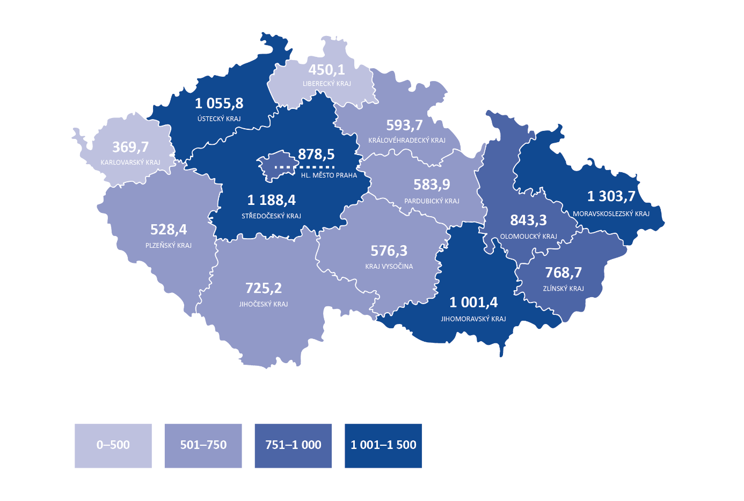

**Source:** OKslužby – poskytovatel (OKservices – provider) application.

# IV. Detailed facts ascertained by the audit

1. **In the period under review, the MoLSA failed to fulfil the declared long-term visions, objectives and measures set out in the basic framework document *National Strategy for the Development of Social Services for 2016-2025*, mainly due to the failure to adopt the amendment to the Social Services Act. Out of 17 measures with a deadline of fulfilment in 2016 and 2017, 14 were not fulfilled by the MoLSA.**

The main strategic documents dealing with social services in the period under review are:

* *Social Inclusion Strategy 2014-2020*,
* *National Strategy for the Development of Social Services for 2015*,
* *National Strategy for the Development of Social Services for 2016-2025*.

The measures resulting from the Social Inclusion Strategy 2014-2020 were supposed to be taken mainly by the end of 2015. Seven of the declared measures were fulfilled, two of the declared measures were only partially fulfilled, and the proposed measure of “*integration of community social work into social service activities*” was not implemented because it is a cross-sectional activity that is implemented by some types of social services.

The NS 2015 was only issued for 2015 and some of its measures were transferred to the NSDSS 2016-2025 in connection with the forthcoming amendment to the Social Services Act. The deadline for fulfilling certain measures was negatively affected by the failure to adopt the amendment to the Social Services Act. A number of measures were transferred to the follow-up *National Strategy for the Development of Social Services for 2016-2025*. Twenty NS 2015 measures were met, ten measures were met partially and one measure was met otherwise. The development of the NS 2015 for only one year can be assessed as a transitional solution for the complex area of social services.

The NSDSS 2016-2025 is a basic strategic document and its global objective is: “*to set up a long-term sustainable system of accessible social services and support of informal care for people in an unfavourable social situation*”. The NSDSS 2016-2025 sets the implementation period for individual measures in the period from 2016 to 2025. The audit of the SAO assessed the continuous fulfilment of 17 measures, which should have been completed in 2016 and 2017, i.e. by the end of the audit. The selected 17 measures were to contribute to 7 of the 10 strategic objectives of the NSDSS 2016-2025, i.e. the overwhelming majority.

Of these 17 measures, the MoLSA failed to fulfil the indicators verifying their fulfilment for 14 of them. These measures were not implemented, and therefore not fulfilled. These included, for example:

* Increasing support for informal carers,
* Legislative definition of requirements for the quality of social services,
* Draft decree regulating the personnel and material standard of social services,
* Draft law on social workers and its implementing regulation,
* Legislation on the professional competences of employees in social services.

Details on the fulfilment of the indicators verified under the audit are given in Annex 1 to this Audit Conclusion.

As of the date of the conclusion of the audit, it can be stated that the MoLSA does not meet the strategic goals formulated in the NSDSS 2016-2025, and thus does not fulfil the long-term objective of setting up a long-term sustainable system of accessible social services and promoting informal care for persons in an unfavourable social situation.

The MoLSA monitors and evaluates the implementation of the national strategy for the development of social services.[16] The process for monitoring and evaluating the fulfilment of objectives and measures is set in both NS 2015 and NSDSS 2016-2025. Among other things, the MoLSA produced annual reports on the fulfilment of the relevant strategic policy tasks and indicated at what stage the work on the measures was.

The MoLSA evaluated the way in which the regions redistributed funds to individual social services. For this, mainly the interim and final subsidy drawing reports are used. The MoLSA evaluated the applications of the regions and the City of Prague for subsidies, evaluated the annual activities of the inspection, used outputs from applications (e.g. the *OKslužby – poskytovatel (OKservices – provider)* application) as a basis for regular reports and analytical work, and provided methodological support to subsidy beneficiaries (regions and the City of Prague).

**The NSDSS 2016-2025, as a basic strategic document, has been approved by the Government of the Czech Republic[17]. The global objective of the NSDSS 2016-2025 is “*to set up a long-term sustainable system of accessible social services and support of informal care for people in an unfavourable social situation*”. The MoLSA has not yet been able to meet this global objective.**

1. **Before the end of the audit, no amendment to the Social Services Act was adopted because major contradictions in the inter-ministerial comment procedure persisted, as repeatedly stated by the Government Legislative Council of the Government in its opinions. According to the *Government Legislative Work Schedule for 2016*, this amendment was supposed to become effective in April 2017.**

Since its effective date on 1 January 2007, the Social Services Act has been amended 44 times. In the period under review 2015-2017, the Social Services Act was amended 6 times.

The reason for the amendment to the Social Services Act was to balance the existing legislation and the current practice, to strengthen the stability of the existing system (especially to remove the uncertainty of providers in connection with the one-year nature of financing), to clarify the definitions and formulations, and to link the quality requirements and the criteria of the standards of quality of social services. The fulfilment of some objectives and measures of the *National Strategy for the Development of Social Services for 2016-2025* was conditional on the adoption of this amendment.

The *Government Legislative Work Schedule for 2016* stipulated, among other things, that the MoLSA should submit a draft law amending the Social Services Act to the Government by the end of June 2016. The MoLSA twice requested a postponement of the original deadline given the ongoing inter-ministerial negotiations, assuming that the law should come into effect on 1 January 2018. The MoLSA initiated an inter-ministerial comment procedure five months later than anticipated by the *Government Legislative Work Schedule for 2016*.

In the framework of the inter-ministerial comment procedure on the amendment to the Social Services Act, 86 % of the commenting entities made crucial comments. All regions made crucial comments. They involved, for example, the transfer of facilities operating under an authorisation pursuant to the Act on the Social and Legal Protection of Children to the scope of the Social Services Act, the newly established institute of forced administration, pastoral and spiritual activities, classification of hospices among types of social services, personal assistance issues, issues of re-registration in the register of social service providers, definition of the term *family*, and the issue of public tender as a tool for ensuring the availability of social services.

The Government Legislative Council in its opinions[18] dated March 2017 repeatedly pointed to persistent contradictions with the commenting entities (ministries, regions, the Union of Towns and Municipalities, the National Council of People with Disabilities of the Czech Republic etc.), which made crucial comments. Nevertheless, on 30 March 2017, the Government submitted to the Chamber of Deputies of the Parliament of the Czech Republic (hereinafter the “Chamber of Deputies”) a draft law amending the Social Services Act, with the anticipated effective date as of 1 January 2018. At that time, it was already obvious that, due to the length of the legislative process in the Chamber of Deputies and due to the coming elections to the Chamber of Deputies, the amendment could not be considered by the Chamber of Deputies of the Parliament of the Czech Republic, and thus could not be adopted.

The deadline according to the *Government Legislative Work Schedule for 2016* was not met, which led to the fact that the amendment to the Social Services Act was not approved by the end of the term of office of the Chamber of Deputies.

The *Government Legislative Work Schedule for 2018*[19] stipulated, among other things, that the MoLSA should submit a draft law amending the Social Services Act to the Government in December 2018, with the anticipated effective date as of June 2019. The *Government Legislative Work Schedule for 2019*[20] again stipulated, among other things, that the MoLSA should submit a draft law amending the Social Services Act to the Government in December 2019, with the anticipated effective date as of January 2021.

**Failure to adopt the amendment to the Social Services Act is an essential limiting factor for the development of the social services system and the solution of the most significant problems in this area, also for the coming period. Failure to adopt this amendment also has a negative impact on the ongoing fulfilment of the *National Strategy for the Development of Social Services for 2016-2025*.**

1. **The total amount of the subsidy is determined by the state budget law for the year in question. The amount of subsidies to individual regions is set by the MoLSA in the amount of the percentage of the region in the total annual amount of funds allocated from the state budget to the support of social services for the respective budgetary year. The percentage of each region is listed in an annex to the Social Services Act. The entire process of the subsidy procedure, i.e. the elaboration and submission of applications by the regions and the City of Prague and the evaluation of the applications by the MoLSA, has a minimal effect on the amount of subsidies paid to the regions and the City of Prague.**

The MoLSA provides subsidies to regions and the City of Prague only for the fulfilment of the obligations stipulated in the Social Services Act. It is a specific-purpose subsidy for the financing of current expenditures related to the provision of basic types and forms of social services in the range determined by the basic activities of individual types of social services. The regions and the City of Prague use the received subsidies to provide social services with a local and regional coverage, which are included in the network of social services of the regions and the City of Prague.[21]

After the approval of the state budget for the given year and the allocation of the amount of funds for the provision of social services, the MoLSA determines the amount of the subsidy to the individual regions as a percentage share of the region, which is included in an annex to the Social Services Act, in the total annual amount of funds allocated from the state budget for the support of social services for the relevant budgetary year.

Subsidies can only be provided to the region and the City of Prague on the basis of an application made through a dedicated Internet application. Applications shall include, among other things, the required amount of subsidy and a description of the method of distribution and drawing of the subsidy. The MoLSA evaluates the formal particulars of the applications from the regions and the City of Prague, and the Subsidy Committee of the MoLSA for the provision of non-investment subsidies from the state budget in the field of social services assesses their substantive content. The amount of the subsidy granted may not exceed the amount of the subsidy requested in the individual applications of the regions and the City of Prague. The MoLSA subsequently issues written *decisions to grant a subsidy*[22] with an indication of the amount of the subsidy granted to the regions and the City of Prague.

**The entire process of the subsidy procedure has a minimal effect on the amount of subsidies paid to the regions and the City of Prague, as the amount is based on the state budget law and the distribution of funds for social services is set out in the Social Services Act.**

1. **The MoLSA did not exercise the option provided by law to oblige the regions and the City of Prague to refund any unused subsidy, and could not thus verify whether all the funds provided had been used for the intended purpose. In the period under review it was CZK 90.6 million for which the MoLSA could not evaluate the effectiveness of its use.4**

The subsidy beneficiary (regions and the City of Prague) is obliged to use the special-purpose subsidy in accordance with the *decision to grant a subsidy*. The subsidy beneficiary is obliged to execute the financial settlement in accordance with the Decree[23] and to submit a report on the subsidy drawing in accordance with the Social Services Act. Final subsidy drawing reports include, among other things, the amount refunded by the social service provider to the region in the following year. In the following year after the financial subsidy settlement, individual social service providers refunded any unused portions of the subsidies received to the regions.

In 2016 the regions received, from the unused subsidy granted for 2015, an amount totalling CZK 29,146,381.47, in 2017 the regions received, from the unused subsidy granted for 2016, an amount totalling CZK 29,266,996.93, and in 2018 the regions received, from the unused subsidy granted for 2017, an amount totalling CZK 32,228,191.93. Unused subsidies for the years 2015, 2016 and 2017 thus amounted to CZK 90,641,540.33, i.e. 0.32 % of the total amount of subsidy granted for those years.

**The MoLSA did not exercise the option provided by law[24] and did not commit the regions and the City of Prague, in the *decisions to grant a subsidy,* to refund, within a specified period, any unused funds that social service providers had returned to the regions and the City of Prague after the end of the subsidy year. The unused funds become part of the budget of the regions and the City of Prague, which manage them under their separate competences.[25]**

**In 2015-2017, there were unspent funds in the amount of CZK 90,641,540.33 that went to the budgets of the regions. The MoLSA could not assess whether those funds exceeding CZK 90 million had been used for the purpose for which they had been provided from the state budget.4**

1. **As part of the administration process of the subsidy procedure, some weaknesses were identified on the part of the MoLSA, namely non-compliance with its own rules set for this subsidy programme, failure to introduce and keep an internal control system, and in the area of checking final subsidy drawing reports.**

The MoLSA did not proceed in accordance with the law[26] because it did not introduce and maintain an internal control system which would point out an unjustified extension of the statutory deadline by the MoLSA for the submission of a final subsidy drawing report and furthermore would allow the MoLSA to timely respond to any non-fulfilment of the obligations of the subsidy beneficiaries arising from the *decision to grant a subsidy*. The statutory deadline for submitting the final subsidy drawing report for 2017 was unlawfully extended for one region.

The MoLSA did not require compliance with the rules it had set itself as the MoLSA:

* Did not report the preliminary results of subsidy procedures for the years 2015, 2016 and 2017 to the subsidy beneficiaries in the form of a letter within 5 working days of the confirmation of the decision of the Subsidy Committee as set out in the methodologies,[27]
* In 21 cases (out of 42) accepted the failure to submit a comment on the financial settlement of the subsidy for 2015-2017 although the subsidy beneficiary had been bound to submit these comments by the *decisions to grant a subsidy*,
* In 31 cases (out of 42) accepted a financial settlement of a subsidy not signed by the statutory representative or other authorised person on the basis of a valid mandate although the subsidy beneficiary had been bound to ensure that signing by the *decisions to grant a subsidy*.

The MoLSA checked the final subsidy drawing reports for the years 2015, 2016 and 2017 only generally. Data from the final subsidy drawing reports are used by the MoLSA as a basis for internal statistics on the overall state of financing of social services in the Czech Republic. Inaccurate data (in 2 cases out of 42) between the values in the final subsidy drawing report and the data in the annex to the final report were not considered by the MoLSA to be serious, and the MoLSA did not require that the regions and the City of Prague ensured a remedy.

1. **As a result of the change in the financing of social services of a local and regional nature since 1 January 2015, the MoLSA does not have the possibility of checking the use of funds by social service providers; the MoLSA only carries out such a check for the regions and the City of Prague. Financial checks of providers are carried out by the regions and the City of Prague under their separate competence. The MoLSA checks social service providers only through an inspection of the provision of social services.**

In 2015, the MoLSA carried out inspections of social service providers retroactively for 2014. Since 1 January 2015, when the financing of social services with a local and regional coverage changed, the MoLSA has been performing inspection activities for subsidy beneficiaries (i.e. for regions and the City of Prague) and inspections of social service providers[28], which were transferred from the regional offices of the Labour Office of the Czech Republic to the MoLSA as of 1 January 2015.[29] Financial checks of social service providers have been carried out by the regions and the City of Prague under their separate competence since 1 January 2015.

In 2017, the MoLSA launched financial checks of regions focusing on the use of subsidies from state budget chapter 313 – *Ministry of Labour and Social Affairs* allocated to regions according to the Social Services Act in 2016.[30] Inspections started in five regions. By the end of the SAO audit, a single inspection had been completed; it concerned the Pilsen Region and had been carried out without the identification of any deficiencies. The inspection focused, for example, on the posting of a special-purpose subsidy, the financial settlement of the special-purpose subsidy and the compliance of the total amount of the subsidy granted with the amount posted in the accounting system. On an audit sample of regional subsidies to social service providers, compliance of the total amount of the subsidy with the amount posted in the accounting system and with the final subsidy drawing report submitted was examined, among other things.

The MoLSA also carries out inspections of the provision of social services. Inspections are a tool of the state for supervising the process of social services and disseminating good practice among service providers. The MoLSA carries out these inspections for registered social service providers. The subject of the inspection is the fulfilment of the obligations stipulated by the Social Services Act[31], checking the quality of the provided social services, the assessment of the particulars of social service contracts and the amount of payments for social services provided for a consideration.[32] The adjustment of the inspection system setting with an emphasis on monitoring the quality of social services is one of the strategic objectives of the NSDSS 2016-2025.

In the absence of an amendment to the Social Services Act that was supposed to define the qualification requirements for the profession of inspector, the MoLSA failed to fulfil some legislative measures of the NSDSS 2016-2025: to legislatively define the qualification requirements for the profession of inspector, to gradually increase the number of social service inspectors allocated to the MoLSA in the framework of the public service, and to legislatively define the requirements for the quality of social services, in particular by measures to strengthen human rights in social services.

**For individual regions and the City of Prague, the MoLSA can only carry out a check of the course of the subsidy procedure. In the period under review, the MoLSA completed the check only in the Pilsen Region out of five financial checks of the state budget funds initiated in the regions.**

**After a change in the way social services are financed, inspections are the only means of the MoLSA to check social service providers. However, the MoLSA has so far failed to ensure the optimal number of inspectors to perform these inspection activities.**

1. **In the case of major residential social services in terms of funds, an analysis of data obtained from the MoLSA system revealed significant differences in the average amounts of subsidies from the state budget per bed in individual regions. In 2017, differences between the lowest and highest average amount of subsidy per bed in individual regions ranged from 79 % for the residential social service of “homes with a special regime” to 208 % for the residential service of “protected housing”.15**

In the Czech Republic there are approximately 2 thousand providers of social services, who have registered about 5.6 thousand social services across 33 types. The most frequent legal forms of social service providers in the period under review were subsidised organisations established by territorial self-government units (about 28 %), public-benefit corporations (16 %), associations (13 %) and municipalities (12 %).6

The number of social services facilities[33] in the period under review ranged from 3,271 in 2015 to 3,404 in 2017. The capacity (number of beds) of these facilities was around 78.5 thousand in 2015 and about 81.5 thousand beds in 2017.[34] The capacity of social service facilities is set out in Annex 5 to this Audit Conclusion.

The number of clients of residential social services in 2015 was around 73 thousand, in 2016 about 75 thousand and in 2017 the number of clients was about 76 thousand.34 The SAO audit of the major residential social services in terms of funds quantified the amount of subsidy to support social services with a local and regional coverage per bed for 2015, 2016 and 2017. These were the following residential social services: homes for seniors, homes for people with disabilities, homes with a special regime, protected housing.7 The average amount of subsidies for these residential social services is given in Annex 6 to this Audit Conclusion.

The amount of subsidy in 2015-2017 for selected types of residential services is increasing, as shown in Chart 3.

The average amount of subsidy per bed in the individual regions in 2017 was: in the social service of *“homes for seniors”* from CZK 56.9 thousand to CZK 105.8 thousand per year and bed, in the social service of *“homes for people with disabilities”* from CZK 88.9 thousand to CZK 255.8 thousand per year and bed, in the social service of *”homes with a special regime”* from CZK 75.3 thousand to CZK 134.5 thousand per year and bed, and in the social service of *”protected housing”* from CZK 66.4 thousand to CZK 204.9 thousand per year and bed.

The average amount of subsidy per bed in *homes for seniors* in 2017 was, in the region with the highest average subsidy amount, 85.96% higher than the average amount of subsidy in the region with the lowest average subsidy amount.

The average amount of subsidy per bed in *homes for people with disabilities* in 2017 was, in the region with the highest average subsidy amount, 187.92% higher than the average amount of subsidy in the region with the lowest average subsidy amount.

The average amount of subsidy per bed in *homes with a special regime* in 2017 was, in the region with the highest average subsidy amount, 78.68% higher than the average amount of subsidy in the region with the lowest average subsidy amount.

The average amount of subsidy per bed in the residential social service of *protected housing* in 2017 was, in the region with the highest average subsidy amount, 208.40% higher than the average amount of subsidy in the region with the lowest average subsidy amount.

**The MoLSA subsidies for financing social services constitute only one of the sources of funding and represent only one of the resources involved in covering compensatory payments.[35] For social service providers, it is essential that the individual public sources of compensation (subsidies, donations, contributions by the founding authority, contributions by legal entities) cover the costs associated with the provision of social services. Therefore, the amount of the MoLSA subsidy per bed is also affected by the amount of other resources, the amount of costs for the administration and operation of the buildings and the varying structure of the clients.**

1. **The personnel situation in the area of social services is affected by the absence of any Social Workers Act. There is an unfavourable situation regarding the remuneration of social workers, which has an impact on the staffing of social services.**

The personnel situation in the area of social services is affected by the absence of any Social Workers Act. The *Government Legislative Work Schedule for 2015* set the MoLSA the legislative task of presenting a substantive draft of the Social Workers Act as early as the middle of 2015. By the end of the SAO audit, it had not been submitted.

One of the legislative measures of the NSDSS 2016-2025 was a draft decree regulating the personnel standard for individual social services, which was to govern the minimum requirements for the staffing of social services (numbers of workers). The original deadline for implementing this legislative measure was 2016. However, the draft decree regulating the personnel standard was not submitted to the legislative process, the measure was not met and the implementation of this measure was postponed to 2020.

The area of remuneration in social services is assessed as very troublesome and problematic in the long term not only by the MoLSA. Professionalism in social services and their administration, ensuring adequate remuneration for social workers and workers in social services, the development of social work and the profession of social worker and the development of the profession of “*worker in social services*” are also among the objectives of the key strategic documents of the MoLSA. The NSDSS 2016-2025 emphasises, among other things, the high demands placed on workers in social services, the low prestige of the profession, the need to adjust the qualification requirements and the need to make changes in the education of workers in social services.

Employees in social services are employed in the public and private sectors, so they receive wages and salaries.

1. **Salaries and wages for selected jobs according to CZ-ISCO9**

|  |  |  |  |  |  |  |  |
| --- | --- | --- | --- | --- | --- | --- | --- |
| Sub-group of employment / category of employment according to CZ-ISCO | **2015** | | **2016** | | | **2017** | |
| Gross monthly salary (average) | Gross monthly wages (average) | Gross monthly salary (average) | Gross monthly wages (average) | | Gross monthly salary (average) | Gross monthly wages (average) |
| CZK/month | | CZK/month | | | CZK/month | |
| 2635 Specialists in social work | 26,818 | 22,499 | 27,992 | | 23,760 | 30,677 | 26,221 |
| 3412 Expert workers in social work | 23,358 | 21,559 | 24,421 | | 21,230 | 27,123 | 24,056 |
| 5321 Nurses and workers in social services in the area of residential care | 19,452 | 18,262 | 20,455 | | 18,873 | 23,575 | 21,259 |
| 5322 Nurses and workers in social services in the area of outpatient and field services and home care | 18,383 | 17,219 | 19,123 | | 17,889 | 22,083 | 20,505 |
| 5329 Personal care workers not included elsewhere in the health and social field | 20,747 | 16,893 | 21,998 | | 17,824 | 24,272 | 19,601 |

**Source:** ISPV – MoLSA information system about average earnings; www.ispv.cz.

**Explanatory notes:**

Wages are the cash remuneration of employees for work performed in the private sector.

Salary is the cash remuneration for the work performed, paid by the state, local government units, state funds, subsidised organisations etc.

2635 Specialists in social work – social workers - specialists in the field of public administration, in health care (except for the disabled), in the area of care for disabled people, care for the elderly (except for the disabled), child and youth care (except for the disabled) specialists in shelters, correctional and other facilities.

3412 Expert workers in social work – social workers in the field of public administration, in health care (except for the care for the disabled), in the area of care for the disabled, in the care of children and youth (except for the care for the disabled), social workers in shelters, correctional and other facilities, social workers in the field of counselling (including pedagogical and psychological counselling).

5321 Nurses and workers in social services in the area of residential care – carers in the field of residential care, direct care workers in the field of residential care.

5322 Nurses and workers in social services in the area of outpatient and field services and home   
care – carers in outpatient and field services and home care, direct care workers in outpatient and field services and carers in home care.

5329 Personal care workers not included elsewhere in the health and social field – laboratory workers, medical orderlies, medical rescue vehicle drivers.

**The average gross wages in all the years of the period under review were lower than the average gross salaries for the selected sub-groups of employment.**

1. **Average gross monthly wages in 2015-2016 in converted numbers**

|  |  |  |  |  |
| --- | --- | --- | --- | --- |
| CR total | Nominal wages | Business sphere | Non-business sphere | 5321 Nurses and workers in social services in the area of residential care (according to CZ-ISCO) |
| in CZK | | | |
| 2015 | 26,591 | 26,538 | 26,831 | 18,262 |
| 2016 | 27,764 | 27,696 | 28,075 | 18,873 |

**Source:** Czech Statistical Office.

**Note:** The data relate only to employees in an employment relationship with the entity providing the required statistical data. They do not include persons exercising public functions, such as Deputies, Senators, members of municipal councils of all grades, judges etc. The data on average wages concern wages posted in this period to be paid.

The average gross monthly wage between 2015 and 2016 of the selected sub-group of employees – nurses and workers in social services in the area of residential care – was about 68 % of the average gross monthly wage in the non-business sphere between 2015 and 2016.

**Although the MoLSA in its strategic documents draws attention to this risk area and despite the fact that salaries and wages increased in the social field in the period under review:**

* **There are persistent differences in the remuneration of employees in the public and private sectors;**
* **The average gross monthly wage between 2015 and 2016 of the selected sub-group of employees “nurses and workers in social services in the area of residential care” was about 68 % of the average gross monthly wage in the non-business sphere.**

1. **Given the demographic development and the ageing population, there will be an increase in demands for the state budget funding and staffing in the area of social services. At present, the MoLSA participates in the financing of social services in the form of subsidies for social services (27 %) and care allowance (20 %).**

The Czech Statistical Office (hereinafter the “CZSO”) prepared the *Projection of the Population of the Czech Republic – 2018-2100*, which was published in November 2018. The aim of the CZSO is, among other things, to outline the direction of future population development and to highlight changes in age composition. The document points out, among other things, that the largest population growth will occur in the 65+ age group and that the total population of the Czech Republic will decrease.

1. **Projection of the population**

|  |  |  |
| --- | --- | --- |
| **Year** | **Total** | **– of which: 65+** |
| **2020** | 10,674,467 | 2,134,342 |
| **2030** | 10,783,895 | 2,403,273 |
| **2040** | 10,742,630 | 2,698,767 |
| **2050** | 10,736,254 | 3,075,587 |
| **2060** | 10,678,941 | 3,195,858 |
| **2070** | 10,504,663 | 2,938,579 |
| **2080** | 10,411,955 | 2,931,216 |
| **2090** | 10,447,883 | 3,047,133 |
| **2100** | 10,522,915 | 3,104,179 |

**Source:** CZSO – Projection of the Population of the Czech Republic – 2018-2100, Movement of the population and Age composition of the population by age group, both sexes, medium variant; own SAO preparation.

One of the strategic objectives of the NSDSS 2016-2025 is to ensure the long-term sustainability of social services funding to meet the needs of users, with a specific objective being, inter alia, to “*ensure adequate funding for social services including health care*”. The MoLSA has not yet achieved this specific objective (see Section IV, clause 1 of this Audit Conclusion).

The system of financing social services should reflect future demographic developments. At present, the MoLSA participates in the financing of social services in the form of subsidies for social services (27 %) and care allowance (20 %). Details on the composition of sources of financing social services in 2015-2017 are given in Annex 4 to this Audit Conclusion.

**List of abbreviations**

313 – MoLSA state budget chapter 313 – *Ministry of Labour and Social Affairs*

CR (Czech Republic) Czech Republic

CZSO Czech Statistical Office

EU European Union

City of Prague Capital City of Prague

Inspection Inspection of the provision of social services

IROP *Integrated Regional Operational Programme*

MoLSA Ministry of Labour and Social Affairs

SAO Supreme Audit Office

NS 2015 *National Strategy for the Development of Social Services for 2015*

NSDSS 2016-2025 *National Strategy for the Development of Social Services for 2016-2025*

OPE Operational Programme *Employment*

Chamber of Deputies Chamber of Deputies of the Parliament of the Czech Republic

RIA Regulatory Impact Assessment

Decision to grant a subsidy Decision to grant a subsidy from state budget chapter 313 – MoLSA

#### **Annex 1**

1. **Selected indicators to check the fulfilment of NSDSS 2016-2025**

| **Measure** | **Output – indicator** | **Date of fulfilment** | **Status as of July 2018** |
| --- | --- | --- | --- |
| A.1.1 | Action plan to promote the transition from institutional care to community support (the so-called transformation of social services) | 2017 |  |
| A.1.2 | Implementation of the plan (transition from institutional care to community support) and check of its performance every quarter | 2017 |  |
| A.2.2 | Announced IROP and OPE calls including support for transformation/deinstitutionalisation and social services of community character | 2016 |  |
| B.1.4 | Analysis of the possibilities of introducing a multi-year funding system | 2017 |  |
| B.2.5 | Setting the financial amount for the state budget for 2017 | 2016 |  |
| B.3.1 | Ensuring adequate financing of social services including health care by an amendment to Act No. 108/2006 Coll., on Social Services | 2016 |  |
| B.5.1 | Amendment to Government Regulation No. 564/2006 Coll., on the Remuneration of Employees in Public Services and Administration | 2016 |  |
| D.1.1 | Draft amendment to the law governing the care allowance and the RIA | 2017 |  |
| D.4.1 | Amendment to Act No. 108/2006 Coll., on Social Services, to increase the support of informal carers by the public administration | 2017 |  |
| E.1.2 | Amendment to Act No. 108/2006 Coll., on Social Services, with a view to provide a legislative definition of the requirements for the quality of social services | 2016 |  |
| E.2.3 | Amendment to Act No. 108/2006 Coll., on Social Services, in order to ensure a unified approach of the inspection | 2016 |  |
| F.2.1 | Draft decree governing the personnel standard submitted to the legislative process; goal: to define personnel and material standards for individual social services | 2016 |  |
| F.2.2 | Draft decree governing the material standard submitted to the legislative process; goal: to define personnel and material standards for individual social services | 2016 |  |
| G.1.1 | Social Workers Act; goal: to define personnel and material standards for individual social services | 2016 |  |
| G.1.2 | Implementing regulation to the Social Workers Act; goal: to define personnel and material standards for individual social services | 2017 |  |
| G.4.1 | Amendment to Act No. 108/2006 Coll., on Social Services, with a view to developing the occupation of workers in social services | 2016 |  |
| I.1.3 | Methodological Guideline with the aim of unambiguously defining the basic concepts in the laws, decrees and methodological guidelines | 2017 |  |

**Source:** NSDSS 2016-2025, MoLSA – Response to Request No. 9.

**Explanatory notes:**

not fulfilled

partially fulfilled

fulfilled

#### Annex 2

1. **The amount of the MoLSA subsidy in 2017 in CZK per 1 bed for selected residential social services (minimum and maximum values, average)**

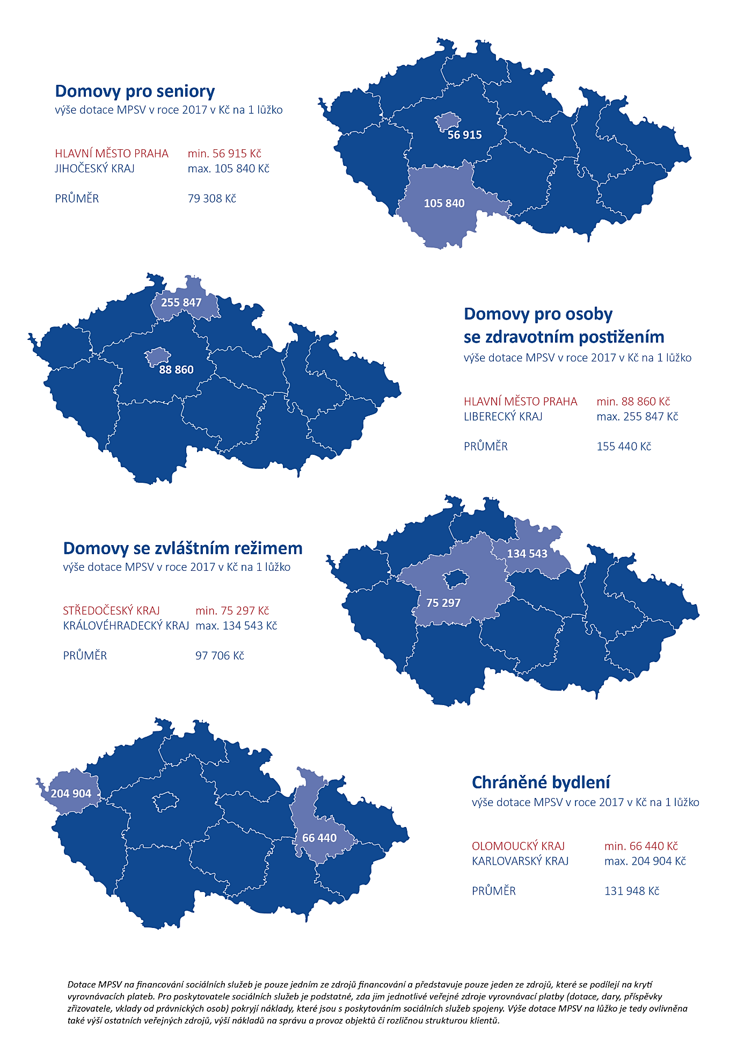

**Homes with a special regime**

Amount of the MoLSA subsidy in 2017 in CZK per 1 bed

|  |  |
| --- | --- |
| CENTRAL BOHEMIAN REGION | minimum CZK 75,297 |
| HRADEC KRÁLOVÉ REGION | maximum CZK 134,543 |
| AVERAGE | CZK 97,706 |

**Protected housing**

Amount of the MoLSA subsidy in 2017 in CZK per 1 bed

|  |  |
| --- | --- |
| OLOMOUC REGION | minimum CZK 66,440 |
| KARLOVY VARY REGION | maximum CZK 204,904 |
| AVERAGE | CZK 131,948 |

**Homes for people with disabilities**

Amount of the MoLSA subsidy in 2017 in CZK per 1 bed

|  |  |
| --- | --- |
| CITY OF PRAGUE | minimum CZK 88,860 |
| LIBEREC REGION | maximum CZK 255,847 |
| AVERAGE | CZK 155,440 |

**Homes for seniors**

Amount of the MoLSA subsidy in 2017 in CZK per 1 bed

|  |  |
| --- | --- |
| CITY OF PRAGUE | minimum CZK 56,915 |
| SOUTH BOHEMIAN REGION | maximum CZK 105,840 |
| AVERAGE | CZK 79,308 |

*The MoLSA subsidies for financing social services constitute only one of the sources of funding and represent only one of the resources involved in covering compensatory payments. For social service providers, it is essential that the individual public sources of compensation (subsidies, donations, contributions by the founding authority, contributions by legal entities) cover the costs associated with the provision of social services. Therefore, the amount of the MoLSA subsidy per bed is also affected by the amount of other public resources, the amount of costs for the administration and operation of the buildings and the varying structure of the clients.*

**Explanatory notes**: Homes for seniors (Section 49 of the Social Services Act) provide residential services to persons who have a reduced self-sufficiency mainly due to their age and whose situation requires regular assistance by another individual. Homes for people with disabilities (Section 48 of the Social Services Act) provide residential services to persons who have a reduced self-sufficiency due to disability and whose situation requires regular assistance by another individual. Homes with a special regime (Section 50 of the Social Services Act) provide residential services to persons who have a reduced self-sufficiency due to chronic mental illness or addiction to addictive substances and to persons with old-age dementia, Alzheimer’s dementia and other types of dementia who have a reduced self-sufficiency due to these diseases and whose situation requires regular assistance by another individual. Protected housing (Section 51 of the Social Services Act) is a residential service provided to persons who have a reduced self-sufficiency due to disability or chronic illness, including mental illness, whose situation requires the assistance by another individual. Protected housing takes the form of group or individual housing.

#### Annex 3

1. **Types of social service facilities**

|  |
| --- |
| **Social service facilities** |
| Day care centres |
| Day social welfare institutions |
| Week social welfare institutions |
| Homes for people with disabilities |
| Homes for seniors |
| Homes with a special regime |
| Protected housing |
| Shelters |
| Half-way houses |
| Crisis assistance facilities |
| Low-threshold day centres |
| Low-threshold facilities for children and youth |
| Dormitories |
| Therapeutic communities |
| Social counselling |
| Social therapy workshops |
| Centres of social rehabilitation services |
| Early care workplace |
| Intervention centres |
| Subsequent care facilities |

**Source:** Section 34 of Act No. 108/2006 Coll., on Social Services.

1. **Types of social services under the Social Services Act**

|  |  |
| --- | --- |
| **Type of social service** | **Basic areas** |
| Basic social counselling[36] | Social counselling |
| Expert social counselling |
| Personal assistance | Social care services |
| Care service |
| Emergency care |
| Guiding and reading services |
| Support for independent housing |
| Relief services |
| Day care centres |
| Day social welfare institutions |
| Week social welfare institutions |
| Homes for people with disabilities |
| Homes for seniors |
| Homes with a special regime |
| Protected housing |
| Social services provided in inpatient medical facilities |
| Early care | Social prevention services |
| Telephone crisis assistance |
| Interpreting services |
| Shelters |
| Half-way houses |
| Contact centres |
| Crisis assistance |
| Intervention centres |
| Low-threshold day centres |
| Low-threshold facilities for children and youth |
| Dormitories |
| Subsequent care services |
| Social activation services for families with children |
| Social activation services for seniors and people with disabilities |
| Social therapy workshops |
| Therapeutic communities |
| Field programmes |
| Social rehabilitation |

**Source:** Act No. 108/2006 Coll., on Social Services.

#### Annex 4

1. **Sources of financing social services in 2015**

Other

**CZK 1.54 billion**

EU funds

**CZK 0.59 billion**

Office of the Government of the Czech Republic, Labour Office of the Czech Republic, other ministries

**CZK 0.51 billion**

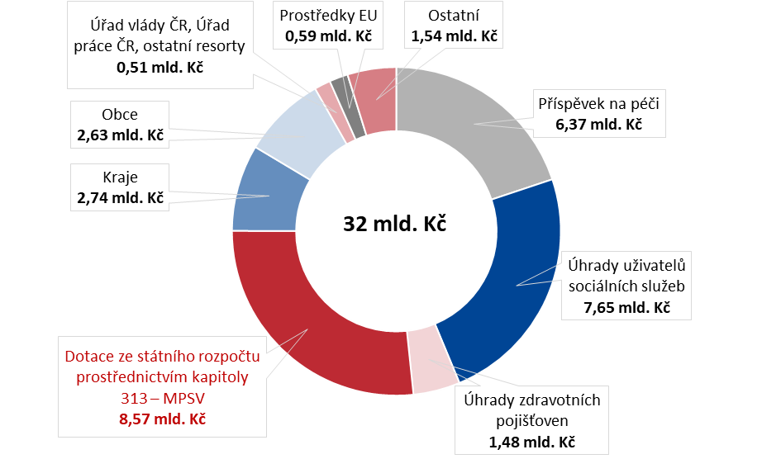

**CZK 32 billion**

Subsidies from the state budget through chapter 313 – MoLSA

**CZK 8.57 billion**

Payments of health insurance companies

**CZK 1.48 billion**

Payments of social service users

**CZK 7.65 billion**

Regions

**CZK 2.74 billion**

Municipalities

**CZK 2.63 billion**

Care allowance

**CZK 6.37 billion**

**Source:** MoLSA, *OKslužby – poskytovatel (OKservices – provider)* application.

**Chart 4: Sources of financing social services in 2016**

EU funds

**CZK 0.38 billion**

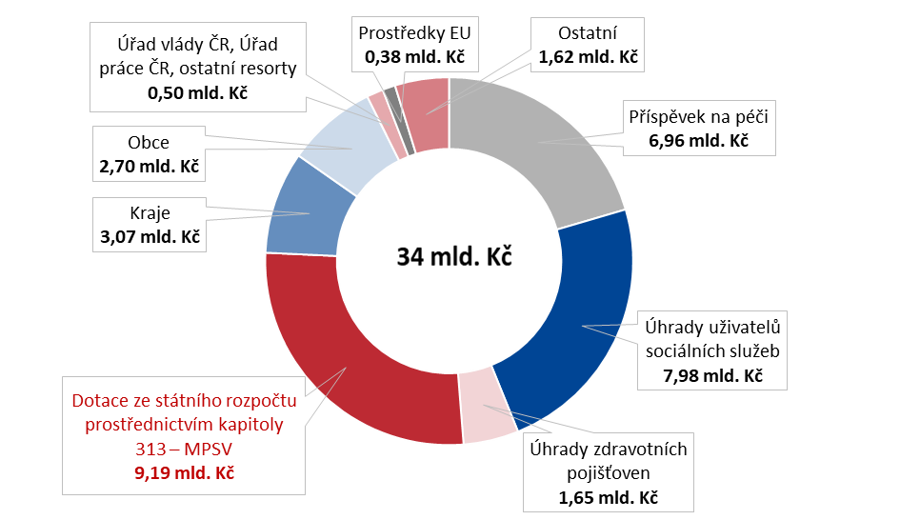

**CZK 34 billion**

Subsidies from the state budget through chapter 313 – MoLSA

**CZK 9.19 billion**

Payments of health insurance companies

**CZK 1.65 billion**

Payments of social service users

**CZK 7.98 billion**

Regions

**CZK 3.07 billion**

Municipalities

**CZK 2.70 billion**

Care allowance

**CZK 6.96 billion**

Other

**CZK 1.62 billion**

Office of the Government of the Czech Republic, Labour Office of the Czech Republic, other ministries

**CZK 0.50 billion**

**Source:** MoLSA, *OKslužby – poskytovatel (OKservices – provider)* application.

1. **Sources of financing social services in 2017**

Other

**CZK 1.71 billion**

EU funds

**CZK 0.85 billion**

Office of the Government of the Czech Republic, Labour Office of the Czech Republic, other ministries

**CZK 0.47 billion**

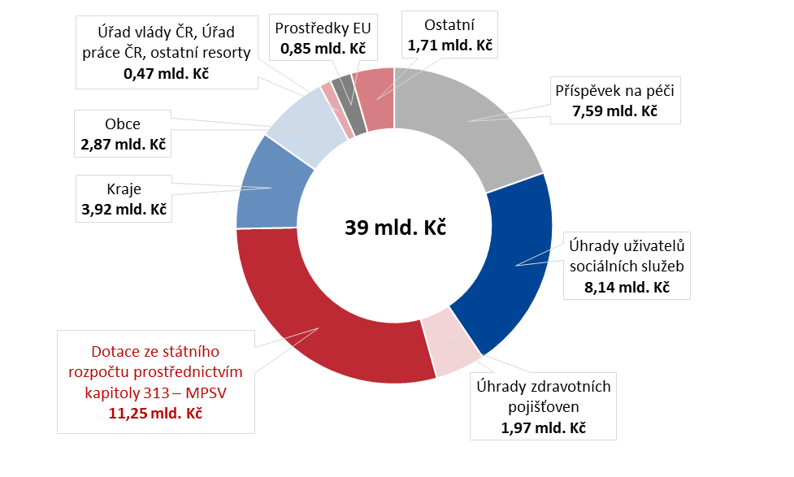**Source:** MoLSA, *OKslužby – poskytovatel (OKservices – provider)* application.

**CZK 39 billion**

Subsidies from the state budget through chapter 313 – MoLSA

**CZK 11.25 billion**

Payments of health insurance companies

**CZK 1.97 billion**

Payments of social service users

**CZK 8.14 billion**

Regions

**CZK 3.92 billion**

Municipalities

**CZK 2.87 billion**

Care allowance

**CZK 7.59 billion**

**Explanatory notes for Charts 3, 4 and 5:**

Other ministries – Ministry of Transport, Ministry of Finance, Ministry of Culture, Ministry of Defence, Ministry of Regional Development, Ministry of Industry and Trade, Ministry of Justice, Ministry of Education, Youth and Sports, Ministry of Health, Ministry of Agriculture, Ministry of the Environment.

EU funds shall mean resources from structural funds and individual projects.

Other – revenues from taxes and fees, sales of products and services, rents, received donations and contributions, other operating and financial revenues.

The care allowance is provided from state budget chapter 313 – MoLSA pursuant to the Social Services Act.

#### Annex 5

1. **Total capacity of each type of service**

|  |  |  |  |  |  |  |
| --- | --- | --- | --- | --- | --- | --- |
| **Type of service**  **(pursuant to Section 34  of Act No. 108/2006 Coll.)** | **2015** | | **2016** | | **2017** | |
| **Total number of services** | **Service capacity**  **(number of beds)** | **Total number of services** | **Service capacity**  **(number of beds)** | **Total number of services** | **Service capacity**  **(number of beds)** |
| Day care centres | 82 | – | 82 | – | 79 | – |
| Day social welfare institutions | 274 | – | 269 | – | 270 | – |
| Week social welfare institutions | 60 | 836 | 57 | 779 | 57 | 868 |
| Homes for people with  disabilities | 212 | 12,707 | 209 | 12,402 | 204 | 12,231 |
| Homes for seniors | 496 | 37,200 | 514 | 37,247 | 519 | 37,037 |
| Homes with a special regime | 276 | 15,494 | 307 | 17,784 | 322 | 18,853 |
| Protected housing | 196 | 3,556 | 205 | 3,898 | 207 | 4,014 |
| Shelters | 215 | 7,311 | 211 | 7,111 | 214 | 7,199 |
| Half-way houses | 34 | 376 | 37 | 408 | 36 | 396 |
| Crisis assistance facilities | 42 | 43 | 41 | 43 | 41 | 42 |
| Low-threshold day centres | 55 | – | 58 | – | 61 | – |
| Low-threshold facilities for children  and youth | 230 | – | 235 | – | 245 | – |
| Dormitories | 72 | – | 76 | – | 76 | – |
| Therapeutic communities | 14 | 243 | 13 | 224 | 14 | 237 |
| Social counselling | 516 | – | 523 | – | 523 | – |
| Social therapy workshops | 140 | – | 152 | – | 152 | – |
| Centres of social rehabilitation services | 257 | 537 | 266 | 283 | 275 | 361 |
| Early care workplace | 43 | – | 43 | – | 47 | – |
| Intervention centres | 18 | – | 18 | – | 18 | – |
| Subsequent care services | 39 | 199 | 42 | 241 | 44 | 265 |
| **Total CR** | **3,271** | **78,502** | **3,358** | **80,420** | **3,404** | **81,503** |

**Source:** MoLSA; CZSO – publications Selected data on social security for 2015 and Selected data on social security for 2016.

#### Annex 6

1. **Amount of subsidy provided for the years 2015, 2016 and 2017 per bed**

|  |  |  |  |  |  |  |
| --- | --- | --- | --- | --- | --- | --- |
| **Region** | **Year** | **Homes for seniors** | | | | |
| **Number of supported providers** | **Number of supported services** | **Supported capacity – number of beds\*** | **Amount of subsidy provided in CZK** | **Subsidy provided in CZK per bed** |
| City of Prague | 2015 | 24 | 25 | 2,529 | 101,994,000.00 | 40,334.56 |
| 2016 | 25 | 28 | 2,580 | 106,689,000.00 | 41,357.13 |
| 2017 | 25 | 29 | 2,597 | 147,815,000.00 | 56,914.97 |
| South Bohemian Region | 2015 | 29 | 36 | 2,955 | 230,171,300.00 | 77,892.15 |
| 2016 | 29 | 35 | 2,890 | 248,390,200.00 | 85,948.17 |
| 2017 | 29 | 34 | 2,842 | 300,796,344.00 | 105,839.67 |
| South Moravian Region | 2015 | 42 | 44 | 2,833 | 167,905,200.00 | 59,267.63 |
| 2016 | 43 | 45 | 2,796 | 159,466,200.00 | 57,033.69 |
| 2017 | 37 | 39 | 2,357 | 152,011,400.00 | 64,493.59 |
| Karlovy Vary Region | 2015 | 15 | 16 | 900 | 56,656,400.00 | 62,951.56 |
| 2016 | 15 | 16 | 895 | 50,320,300.00 | 56,223.80 |
| 2017 | 16 | 17 | 907 | 83,644,100.00 | 92,220.62 |
| Hradec Králové Region | 2015 | 30 | 30 | 2,102 | 125,658,000.00 | 59,780.21 |
| 2016 | 30 | 30 | 2,037 | 141,965,000.00 | 69,693.18 |
| 2017 | 30 | 30 | 1,993 | 178,130,230.00 | 89,377.94 |
| Liberec Region | 2015 | 17 | 17 | 950 | 60,931,000.00 | 64,137.89 |
| 2016 | 17 | 17 | 984 | 61,049,000.00 | 62,041.67 |
| 2017 | 17 | 17 | 952 | 76,069,342.00 | 79,904.77 |
| Moravian-Silesian Region | 2015 | 55 | 63 | 4,575 | 279,996,000.00 | 61,201.31 |
| 2016 | 54 | 62 | 4,514 | 295,987,000.00 | 65,570.89 |
| 2017 | 57 | 63 | 4,466 | 374,195,000.00 | 83,787.51 |
| Olomouc Region | 2015 | 32 | 33 | 2,505 | 169,939,800.00 | 67,840.24 |
| 2016 | 32 | 33 | 2,643 | 188,998,300.00 | 71,509.00 |
| 2017 | 32 | 33 | 2,642 | 236,097,800.00 | 89,363.29 |
| Pardubice Region | 2015 | 18 | 19 | 1,910 | 129,604,000.00 | 67,855.50 |
| 2016 | 18 | 19 | 1,837 | 130,777,000.00 | 71,190.53 |
| 2017 | 20 | 22 | 1,996 | 161,480,000.00 | 80,917.21 |
| Pilsen Region | 2015 | 18 | 24 | 1,815 | 119,848,409.00 | 66,032.18 |
| 2016 | 18 | 24 | 1,785 | 100,018,919.00 | 56,033.01 |
| 2017 | 18 | 23 | 1,712 | 138,252,276.00 | 80,754.83 |
| Central Bohemian Region | 2015 | 59 | 61 | 4,749 | 237,812,200.00 | 50,079.43 |
| 2016 | 58 | 60 | 4,611 | 261,680,800.00 | 56,755.11 |
| 2017 | 58 | 60 | 4,643 | 371,023,900.00 | 79,912.45 |
| Ústí Region | 2015 | 30 | 35 | 3,519 | 174,211,902.32 | 49,506.08 |
| 2016 | 31 | 35 | 3,353 | 128,707,900.00 | 38,385.89 |
| 2017 | 32 | 36 | 3,282 | 187,767,869.00 | 57,211.42 |
| Vysočina Region | 2015 | 24 | 24 | 2,116 | 142,309,100.00 | 67,253.83 |
| 2016 | 23 | 23 | 2,044 | 135,664,000.00 | 66,371.82 |
| 2017 | 23 | 23 | 2,003 | 161,240,835.00 | 80,499.67 |
| Zlín Region | 2015 | 23 | 35 | 2,642 | 128,156,270.00 | 48,507.29 |
| 2016 | 23 | 36 | 2,436 | 146,892,900.00 | 60,300.86 |
| 2017 | 22 | 35 | 2,401 | 190,794,000.00 | 79,464.39 |
| **Total** | **2015** | **x** | **462** | **36,099** | **2,125,193,581.32** | **58,870.61** |
| **2016** | **x** | **463** | **35,404** | **2,156,606,519.00** | **60,913.52** |
| **2017** | **x** | **461** | **34,793** | **2,759,318,096.00** | **79,307.57** |

**Source:** *OKslužby – poskytovatel (OKservices – provider)* application, own calculation of the SAO.

* Some social service facilities provide their services to clients from more than one region, therefore the shares of the individual regions in the total amount of the requested subsidy were taken into account in the calculation. The calculation of the subsidy provided per bed took account of the supported bed capacity and the result was rounded to two decimal places.

**Table 10:Amount of subsidy provided for the years 2015, 2016 and 2017 per bed**

|  |  |  |  |  |  |  |
| --- | --- | --- | --- | --- | --- | --- |
| **Region** | **Year** | **Homes for people with disabilities** | | | | |
| **Number of supported providers** | **Number of supported services** | **Supported capacity – number of beds\*** | **Amount of subsidy provided in CZK** | **Subsidy provided in CZK per bed** |
| City of Prague | 2015 | 15 | 15 | 1,111 | 74,363,000.00 | 66,933.39 |
| 2016 | 16 | 16 | 1,121 | 82,942,000.00 | 73,990.13 |
| 2017 | 14 | 14 | 897 | 79,707,000.00 | 88,860.31 |
| South Bohemian Region | 2015 | 7 | 8 | 623 | 71,109,800.00 | 114,122.61 |
| 2016 | 8 | 8 | 578 | 69,099,400.00 | 119,547.07 |
| 2017 | 7 | 7 | 576 | 87,289,367.00 | 151,544.04 |
| South Moravian Region | 2015 | 12 | 16 | 1,096 | 127,118,800.00 | 115,984.31 |
| 2016 | 12 | 16 | 990 | 110,793,741.23 | 111,912.87 |
| 2017 | 12 | 15 | 962 | 136,917,900.00 | 142,326.30 |
| Karlovy Vary Region | 2015 | 7 | 7 | 418 | 58,069,900.00 | 138,923.21 |
| 2016 | 7 | 7 | 398 | 50,785,600.00 | 127,602.01 |
| 2017 | 7 | 7 | 379 | 66,916,900.00 | 176,561.74 |
| Hradec Králové Region | 2015 | 11 | 11 | 705 | 102,574,000.00 | 145,495.04 |
| 2016 | 10 | 10 | 676 | 93,491,000.00 | 138,300.30 |
| 2017 | 10 | 10 | 669 | 113,299,740.00 | 169,356.86 |
| Liberec Region | 2015 | 9 | 12 | 280 | 54,670,000.00 | 195,250.00 |
| 2016 | 9 | 9 | 293 | 56,190,000.00 | 191,774.74 |
| 2017 | 9 | 9 | 292 | 74,707,228.00 | 255,846.67 |
| Moravian-Silesian Region | 2015 | 16 | 27 | 1,093 | 155,294,000.00 | 142,080.51 |
| 2016 | 15 | 29 | 1,026 | 167,407,000.00 | 163,164.72 |
| 2017 | 16 | 24 | 1,032 | 205,589,000.00 | 199,214.15 |
| Olomouc Region | 2015 | 11 | 11 | 1,080 | 131,387,300.00 | 121,654.91 |
| 2016 | 10 | 10 | 1,057 | 136,615,641.00 | 129,248.48 |
| 2017 | 10 | 10 | 1,041 | 151,651,200.00 | 145,678.39 |
| Pardubice Region | 2015 | 8 | 8 | 725 | 93,149,000.00 | 128,481.38 |
| 2016 | 8 | 8 | 673 | 101,755,000.00 | 151,196.14 |
| 2017 | 8 | 8 | 648 | 116,867,000.00 | 180,350.31 |
| Pilsen Region | 2015 | 9 | 9 | 882 | 82,168,645.00 | 93,151.17 |
| 2016 | 9 | 9 | 865 | 88,657,869.00 | 102,493.46 |
| 2017 | 9 | 9 | 873 | 100,124,017.00 | 114,689.60 |
| Central Bohemian Region | 2015 | 21 | 21 | 1,053 | 136,416,900.00 | 129,501.52 |
| 2016 | 21 | 21 | 1,066 | 145,987,200.00 | 136,897.22 |
| 2017 | 20 | 20 | 1,072 | 183,079,149.00 | 170,750.93 |
| Ústí Region | 2015 | 21 | 32 | 1,446 | 173,377,000.00 | 119,901.11 |
| 2016 | 21 | 31 | 1,362 | 146,674,600.00 | 107,690.60 |
| 2017 | 21 | 31 | 1,354 | 175,365,264.41 | 129,516.44 |
| Vysočina Region | 2015 | 9 | 9 | 579 | 85,219,000.00 | 147,183.07 |
| 2016 | 9 | 9 | 569 | 83,052,000.00 | 145,961.34 |
| 2017 | 9 | 9 | 571 | 100,557,500.00 | 176,107.71 |
| Zlín Region | 2015 | 7 | 18 | 1,096 | 129,670,600.00 | 118,312.59 |
| 2016 | 7 | 18 | 991 | 130,143,800.00 | 131,325.73 |
| 2017 | 7 | 18 | 946 | 166,296,500.00 | 175,789.11 |
| **Total** | **2015** | **x** | **204** | **12,188** | **1,474,587,945.00** | **120,990.84** |
| **2016** | **x** | **201** | **11,665** | **1,463,594,851.23** | **125,464.53** |
| **2017** | **x** | **191** | **11,312** | **1,758,367,765.41** | **155,440.06** |

**Source:** *OKslužby – poskytovatel (OKservices – provider)* application, own calculation of the SAO.

* Some social service facilities provide their services to clients from more than one region, therefore the shares of the individual regions in the total amount of the requested subsidy were taken into account in the calculation. The calculation of the subsidy provided per bed took account of the supported bed capacity and the result was rounded to two decimal places.

1. **Amount of subsidy provided for the years 2015, 2016 and 2017 per bed**

|  |  |  |  |  |  |  |
| --- | --- | --- | --- | --- | --- | --- |
| **Region** | **Year** | **Homes with a special regime** | | | | |
| **Number of supported providers** | **Number of supported services** | **Supported capacity – number of beds\*** | **Amount of subsidy provided in CZK** | **Subsidy provided in CZK per bed** |
| City of Prague | 2015 | 17 | 17 | 1,056 | 69,651,000.00 | 65,944.90 |
| 2016 | 17 | 18 | 1,104 | 74,040,000.00 | 67,089.56 |
| 2017 | 16 | 17 | 1,088 | 97,936,000.00 | 90,047.85 |
| South Bohemian Region | 2015 | 11 | 11 | 417 | 39,894,200.00 | 95,669.54 |
| 2016 | 13 | 13 | 471 | 44,973,000.00 | 95,585.55 |
| 2017 | 13 | 13 | 612 | 61,191,252.00 | 99,985.71 |
| South Moravian Region | 2015 | 32 | 33 | 2,579 | 187,540,500.00 | 72,718.30 |
| 2016 | 34 | 35 | 2,817 | 200,412,273.54 | 71,143.87 |
| 2017 | 35 | 36 | 2,948 | 230,591,781.00 | 78,219.74 |
| Karlovy Vary Region | 2015 | 7 | 7 | 359 | 28,405,300.00 | 79,123.40 |
| 2016 | 8 | 8 | 369 | 27,129,500.00 | 73,521.68 |
| 2017 | 8 | 8 | 371 | 39,061,200.00 | 105,286.25 |
| Hradec Králové Region | 2015 | 10 | 10 | 439 | 47,074,000.00 | 107,230.07 |
| 2016 | 10 | 10 | 498 | 56,522,000.00 | 113,497.99 |
| 2017 | 10 | 10 | 493 | 66,329,600.00 | 134,542.80 |
| Liberec Region | 2015 | 9 | 9 | 372 | 28,173,000.00 | 75,733.87 |
| 2016 | 11 | 11 | 524 | 36,678,000.00 | 69,996.18 |
| 2017 | 11 | 11 | 556 | 52,684,560.00 | 94,756.40 |
| Moravian-Silesian Region | 2015 | 30 | 31 | 1,353 | 113,035,876.00 | 83,544.62 |
| 2016 | 31 | 33 | 1,453 | 125,302,167.00 | 86,236.87 |
| 2017 | 33 | 35 | 1,568 | 160,917,000.00 | 102,625.64 |
| Olomouc Region | 2015 | 13 | 13 | 646 | 56,642,000.00 | 87,681.11 |
| 2016 | 15 | 15 | 731 | 74,344,707.00 | 101,702.75 |
| 2017 | 15 | 15 | 731 | 89,685,200.00 | 122,688.37 |
| Pardubice Region | 2015 | 9 | 9 | 563 | 47,880,000.00 | 85,044.40 |
| 2016 | 9 | 9 | 534 | 55,115,000.00 | 103,211.61 |
| 2017 | 10 | 10 | 585 | 71,938,000.00 | 122,970.94 |
| Pilsen Region | 2015 | 7 | 9 | 741 | 42,272,672.00 | 57,048.14 |
| 2016 | 8 | 10 | 809 | 57,976,303.00 | 71,664.16 |
| 2017 | 8 | 10 | 863 | 69,268,986.00 | 80,265.34 |
| Central Bohemian Region | 2015 | 30 | 31 | 1,191 | 51,059,800.00 | 42,882.17 |
| 2016 | 28 | 30 | 1,260 | 68,832,200.00 | 54,624.39 |
| 2017 | 28 | 30 | 1,351 | 101,726,800.00 | 75,297.41 |
| Ústí Region | 2015 | 27 | 29 | 1,385 | 94,097,603.00 | 67,940.51 |
| 2016 | 28 | 30 | 1,571 | 133,614,100.00 | 85,050.35 |
| 2017 | 29 | 31 | 1,675 | 170,824,610.00 | 101,984.84 |
| Vysočina Region | 2015 | 16 | 16 | 559 | 47,446,100.00 | 84,876.74 |
| 2016 | 17 | 17 | 630 | 58,086,000.00 | 92,200.00 |
| 2017 | 18 | 18 | 667 | 77,021,000.00 | 115,473.76 |
| Zlín Region | 2015 | 14 | 17 | 746 | 73,321,930.00 | 98,286.77 |
| 2016 | 15 | 18 | 828 | 90,917,800.00 | 109,804.11 |
| 2017 | 16 | 21 | 905 | 119,015,500.00 | 131,508.84 |
| **Total** | **2015** | **x** | **242** | **12,406** | **926,493,981.00** | **74,681.72** |
| **2016** | **x** | **257** | **13,598** | **1,103,943,050.54** | **81,183.03** |
| **2017** | **x** | **265** | **14,413** | **1,408,191,489.00** | **97,705.59** |

**Source:** *OKslužby – poskytovatel (OKservices – provider)* application, own calculation of the SAO.

* Some social service facilities provide their services to clients from more than one region, therefore the shares of the individual regions in the total amount of the requested subsidy were taken into account in the calculation. The calculation of the subsidy provided per bed took account of the supported bed capacity and the result was rounded to two decimal places.

1. **Amount of subsidy provided for the years 2015, 2016 and 2017 per bed**

|  |  |  |  |  |  |  |
| --- | --- | --- | --- | --- | --- | --- |
| **Region** | **Year** | **Protected housing** | | | | |
| **Number of supported providers** | **Number of supported services** | **Supported capacity – number of beds\*** | **Amount of subsidy provided in CZK** | **Subsidy provided in CZK per bed** |
| City of Prague | 2015 | 16 | 19 | 292 | 30,669,000.00 | 105,102.81 |
| 2016 | 15 | 18 | 290 | 29,438,000.00 | 101,510.34 |
| 2017 | 15 | 17 | 261 | 34,263,000.00 | 131,275.86 |
| South Bohemian Region | 2015 | 10 | 11 | 198 | 16,690,803.00 | 84,296.98 |
| 2016 | 10 | 12 | 259 | 25,683,354.00 | 99,163.53 |
| 2017 | 9 | 10 | 249 | 32,972,515.00 | 132,419.74 |
| South Moravian Region | 2015 | 12 | 17 | 217 | 16,815,900.00 | 77,492.63 |
| 2016 | 15 | 21 | 292 | 28,950,946.00 | 99,147.08 |
| 2017 | 17 | 24 | 312 | 41,426,513.00 | 132,777.29 |
| Karlovy Vary Region | 2015 | 3 | 4 | 84 | 8,879,966.00 | 105,713.88 |
| 2016 | 3 | 4 | 78 | 11,699,600.00 | 149,994.87 |
| 2017 | 3 | 4 | 78 | 15,982,500.00 | 204,903.85 |
| Hradec Králové Region | 2015 | 9 | 9 | 109 | 17,259,000.00 | 158,339.45 |
| 2016 | 9 | 9 | 129 | 20,220,000.00 | 156,744.19 |
| 2017 | 10 | 10 | 144 | 23,071,950.00 | 160,221.88 |
| Liberec Region | 2015 | 4 | 4 | 111 | 11,002,000.00 | 99,117.12 |
| 2016 | 4 | 4 | 113 | 11,288,000.00 | 99,893.81 |
| 2017 | 4 | 4 | 117 | 13,089,598.00 | 111,876.91 |
| Moravian-Silesian Region | 2015 | 17 | 32 | 502 | 44,089,000.00 | 87,826.69 |
| 2016 | 18 | 34 | 553 | 56,971,000.00 | 103,021.70 |
| 2017 | 20 | 32 | 551 | 70,971,000.00 | 128,803.99 |
| Olomouc Region | 2015 | 10 | 10 | 407 | 16,203,044.00 | 39,810.92 |
| 2016 | 12 | 12 | 370 | 18,367,708.00 | 49,642.45 |
| 2017 | 13 | 13 | 375 | 24,915,000.00 | 66,440.00 |
| Pardubice Region | 2015 | 7 | 7 | 125 | 7,673,000.00 | 61,384.00 |
| 2016 | 8 | 8 | 139 | 11,478,000.00 | 82,575.54 |
| 2017 | 8 | 8 | 143 | 14,890,000.00 | 104,125.87 |
| Pilsen Region | 2015 | 4 | 5 | 91 | 6,291,649.56 | 69,139.01 |
| 2016 | 4 | 5 | 91 | 6,409,537.00 | 70,434.47 |
| 2017 | 4 | 4 | 88 | 9,273,026.00 | 105,375.30 |
| Central Bohemian Region | 2015 | 28 | 29 | 546 | 59,031,287.00 | 108,049.42 |
| 2016 | 25 | 26 | 473 | 57,596,886.00 | 121,743.58 |
| 2017 | 23 | 24 | 474 | 75,257,220.00 | 158,770.51 |
| Ústí Region | 2015 | 18 | 21 | 411 | 44,168,165.00 | 107,465.12 |
| 2016 | 18 | 21 | 453 | 52,159,894.00 | 115,143.25 |
| 2017 | 19 | 22 | 467 | 59,656,053.50 | 127,743.16 |
| Vysočina Region | 2015 | 10 | 11 | 157 | 21,820,400.00 | 138,983.44 |
| 2016 | 11 | 12 | 183 | 26,738,500.00 | 146,112.02 |
| 2017 | 11 | 12 | 183 | 28,948,000.00 | 158,185.79 |
| Zlín Region | 2015 | 5 | 7 | 80 | 5,635,390.00 | 70,442.38 |
| 2016 | 6 | 12 | 134 | 15,419,800.00 | 115,073.13 |
| 2017 | 6 | 12 | 142 | 28,183,800.00 | 198,477.46 |
| **Total** | **2015** | **x** | **186** | **3,330** | **306,228,604.56** | **91,956.79** |
| **2016** | **x** | **198** | **3,557** | **372,421,225.00** | **104,697.99** |
| **2017** | **x** | **196** | **3,584** | **472,900,175.50** | **131,947.59** |

**Source:** *OKslužby – poskytovatel (OKservices – provider)* application, own calculation of the SAO.

* Some social service facilities provide their services to clients from more than one region, therefore the shares of the individual regions in the total amount of the requested subsidy were taken into account in the calculation. The calculation of the subsidy provided per bed took account of the supported bed capacity and the result was rounded to two decimal places.

1. **Amount of subsidy provided per bed in homes for seniors in individual regions in 2017**

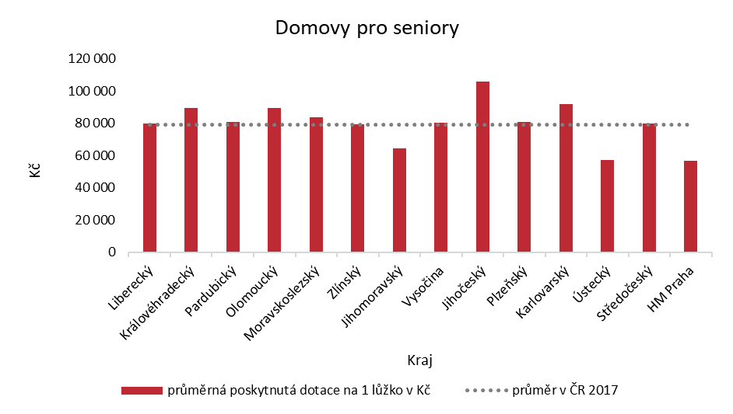

Region

Liberec

Hradec Králové

Pardubice

Olomouc

Moravian-Silesian

Zlín

South Moravian

Vysočina

South Bohemian

Pilsen

Karlovy Vary

Ústí

Central Bohemian

City of Prague

CZK

Average in the CR 2017

Average subsidy per 1 bed in CZK

Homes for seniors

**Source:** *OKslužby – poskytovatel (OKservices – provider)* application.

1. **Amount of subsidy provided per bed in homes for people with disabilities in individual regions in 2017**

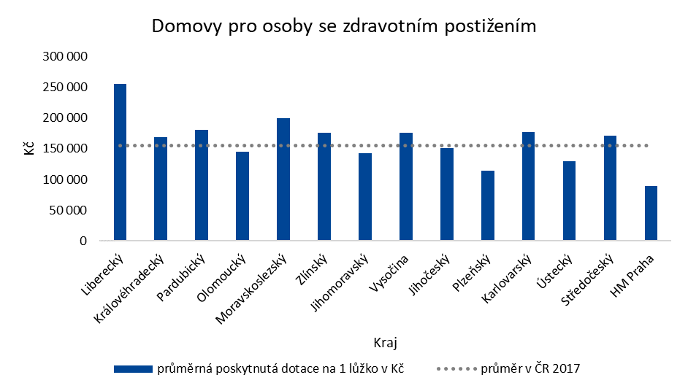

Region

Liberec

Hradec Králové

Pardubice

Olomouc

Moravian-Silesian

Zlín

South Moravian

Vysočina

South Bohemian

Pilsen

Karlovy Vary

Ústí

Central Bohemian

City of Prague

CZK

Average in the CR 2017

Average subsidy per 1 bed in CZK

Homes for people with disabilities

**Source:** *OKslužby – poskytovatel (OKservices – provider)* application.

1. **Amount of subsidy provided per bed in homes with a special regime in individual regions in 2017**

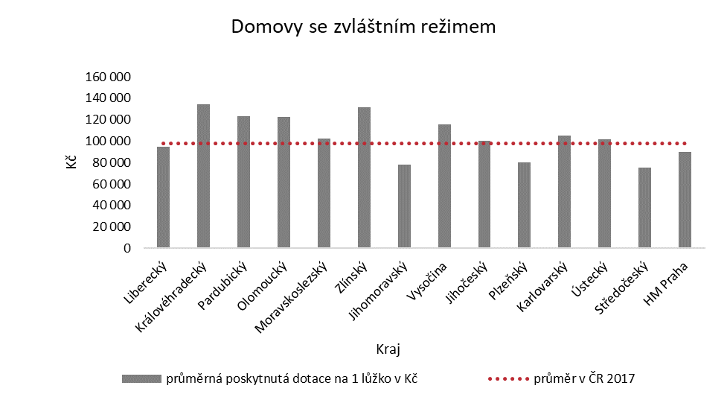

Region

Liberec

Hradec Králové

Pardubice

Olomouc

Moravian-Silesian

Zlín

South Moravian

Vysočina

South Bohemian

Pilsen

Karlovy Vary

Ústí

Central Bohemian

City of Prague

CZK

Average in the CR 2017

Average subsidy per 1 bed in CZK

Homes with a special regime

**Source:** *OKslužby – poskytovatel (OKservices – provider)* application.

1. **Amount of subsidy provided per bed in protected housing in individual regions in 2017**

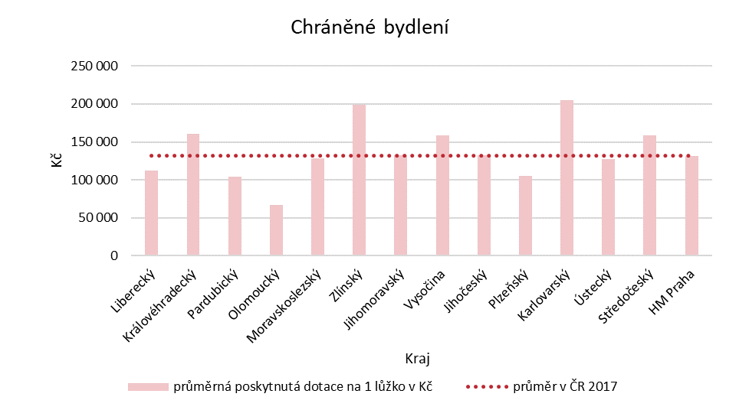

Liberec

Hradec Králové

Pardubice

Olomouc

Moravian-Silesian

Zlín

South Moravian

Vysočina

South Bohemian

Pilsen

Karlovy Vary

Ústí

Central Bohemian

City of Prague

Region

CZK

Average subsidy per 1 bed in CZK

Average in the CR 2017

Protected housing

**Source:** *OKslužby – poskytovatel (OKservices – provider)* application.

1. Act No. 108/2006 Coll., on Social Services.
2. *Social Inclusion Strategy 2014-2020*, *National Strategy for the Development of Social Services for 2015*, *National Strategy for the Development of Social Services for 2016-2025*.
3. Section 14(8) of Act No. 218/2000 Coll., on Budgetary Rules and on Amendments to Certain Related Acts (Budgetary Rules).
4. Section 39(1) and (3) of Act No. 218/2000 Coll., on Budgetary Rules and on Amendments to Certain Related Acts (Budgetary Rules).
5. Sections 97-99 of Act No. 108/2006 Coll., on Social Services.
6. Source: *OKslužby – poskytovatel (OKservices – provider)* application.
7. The calculation used the value of the subsidies paid to the individual social service providers indicated in the *OKslužby – poskytovatel (OKservices – provider)* applicationand forming part of the final subsidy drawing reports. The amount does not include any subsidy that the social service providers have returned to the regions. The service capacity data were taken from applications submitted by social service providers through the *OKslužby – poskytovatel (OKservices – provider)* application. Only supported services were included in the total capacity of the service, i.e. services for which no subsidy had been provided were not included in the total capacity. Furthermore, the shares of individual regions in the total amount of the requested subsidy were taken into account.
8. See also Annex 2 to the Audit Conclusion.
9. Classification of employment according to CZ-ISCO.
10. Decree No. 505/2006 Coll., implementing some provisions of the Social Services Act.
11. Government Regulation No. 98/2015 Coll., on the implementation of Section 101a of the Social Services Act, dated 22 April 2015. This Regulation came into effect on 1 May 2015 and was first used to provide subsidies for 2016.
12. Act No. 2/1969 Coll., on the Establishment of Ministries and Other Central Authorities of the State Administration of the Czech Republic.
13. Pursuant to Section 101a of Act No. 108/2006 Coll., on Social Services; in previous years referred to as Support Programme A.
14. Pursuant to Section 104 of Act No. 108/2006 Coll., on Social Services; in previous years referred to as *Support Programme B*.
15. The audit authority of the SAO pursuant to Act No. 166/1993 Coll., on the Supreme Audit Office, does not allow an audit of subsidies provided by the regions / the City of Prague to social service providers.
16. Pursuant to Section 96 of Act No. 108/2006 Coll., on Social Services.
17. Government Resolution of the Czech Republic dated 21 March 2016 No. 245.
18. The first opinion of the Government Legislative Council is dated 9 March 2017, the second opinion 16 March 2017.
19. Government Legislative Work Schedule for 2018 approved by Resolution of the Government of the Czech Republic of 7 February 2018 No. 91.
20. *Government Legislative Work Schedule for 2019* approved by Resolution of the Government of the Czech Republic of 12 December 2018 No. 830.
21. The social services network is a sum of social services that, in sufficient capacity, quality and with local availability, help to address the unfavourable social situation in the region.
22. Decision to grant a subsidy from state budget chapter 313 – MoLSA for 2015, 2016 or 2017 (hereinafter the “decision to grant a subsidy”).
23. Decree No. 367/2015 Coll., on principles and deadlines for financial settlement of relations with the state budget, state financial assets and the National Fund (Financial Settlement Decree).
24. Section 14(8) of Act No. 218/2000 Coll., on Budgetary Rules and on Amendments to Certain Related Acts (Budgetary Rules).
25. Pursuant to Section 2(1) of Act No. 129/2000 Coll., on Regions (Regional Establishment), the region manages its own affairs separately.
26. Section 25(1) of Act No. 320/2001 Coll., on Financial Control in Public Administration and on Amendments to Certain Acts (Financial Control Act).
27. *Methodology of the Ministry of Labour and Social Affairs for granting subsidies from the state budget to the regions and the City of Prague for 2015*, *Methodology of the Ministry of Labour and Social Affairs for granting subsidies from the state budget to the regions and the City of Prague for 2016* and *Methodology of the Ministry of Labour and Social Affairs for granting subsidies from the state budget to the regions and the City of Prague for 2017*.
28. For providers who have been issued a decision on registration and also for social service providers pursuant to Section 84 of Act No. 108/2006 Coll., on Social Services.
29. Act No. 254/2014 Coll., amending Act No. 108/2006 Coll., on Social Services, as amended, Act No. 111/2006 Coll., on Assistance in Material Need, as amended, and Act No. 73/2011 Coll., on the Labour Office of the Czech Republic and on Amendments to Related Acts, as amended.
30. Pursuant to Section 101a of Act No. 108/2006 Coll., on Social Services.
31. Pursuant to Section 88 and Section 89 of Act No. 108/2006 Coll., on Social Services.
32. Pursuant to Sections 73-77 of Act No. 108/2006 Coll., on Social Services.
33. Pursuant to Section 34 of Act No. 108/2006 Coll., on Social Services.
34. Source: MoLSA – statistical yearbooks on labour and social affairs for 2015, 2016 and 2017.
35. Social services are financed by means of a compensatory payment provided for in Commission Decision 2012/21/EU of 20 December 2011 on the application of Article 106(2) of the Treaty on the Functioning of the European Union to State aid in the form of public service compensation granted to certain undertakings entrusted with the operation of services of general economic interest, and European Union framework for State aid in the form of public service compensation (2011) (2012/C 8/03). Payments of users and payments of health insurance companies for nursing and rehabilitation medical care do not constitute a compensatory payment.
36. Pursuant to Section 37(2) of Act No. 108/2006 Coll., on Social Services, basic social counselling is a fundamental activity in the provision of all kinds of social services, and social service providers are always obliged to arrange social counselling.